Q1 | Write an SQL query to display all products from a 'products' table and sort them by price in ascending order, similar to how Flipkart lists items from lowest to highest price.
Code | Create table product  CREATE TABLE product ( product_id INT AUTO_INCREMENT, product_name VARCHAR(100), price DECIMAL(10,2), PRIMARY KEY(product_id) );  Insert record  INSERT INTO product(product_name,price) VALUES ('Laptop', 55000), ('Mouse', 500), ('Keyboard', 1200), ('Monitor', 15000), ('Headphones', 2500);  Show table  SELECT * FROM product;  Execute query:  SELECT * FROM products ORDER BY price ASC;
Output | 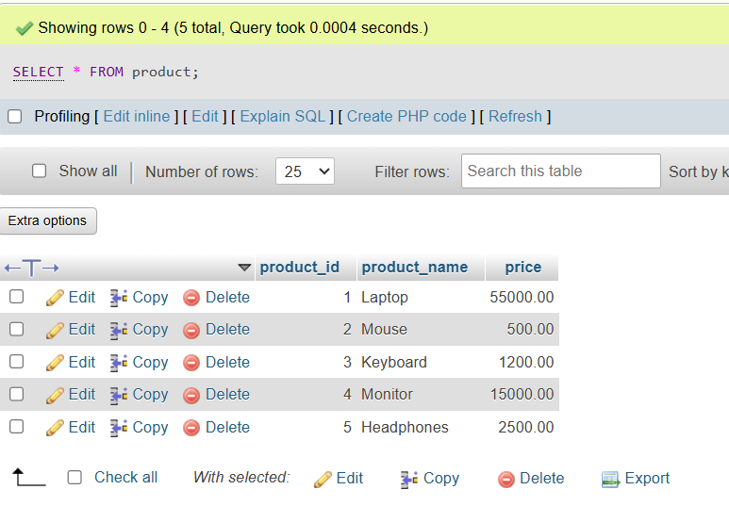  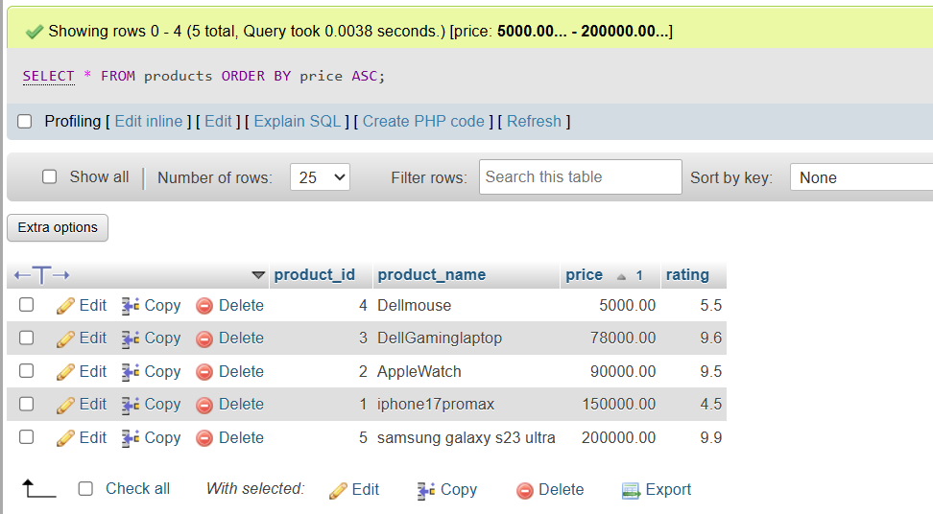

Q2 | Modify your previous query to show the top 5 most expensive products using ORDER BY with DESC and LIMIT.
Code | Use previous table product:  CREATE TABLE product ( product_id INT AUTO_INCREMENT, product_name VARCHAR(100), price DECIMAL(10,2), PRIMARY KEY(product_id) );  Insert record  INSERT INTO product(product_name,price) VALUES ('Laptop', 55000), ('Mouse', 500), ('Keyboard', 1200), ('Monitor', 15000), ('Headphones', 2500);  Show table  SELECT * FROM product;  Execute query:  SELECT * FROM products ORDER BY price DESC LIMIT 5;
Output |   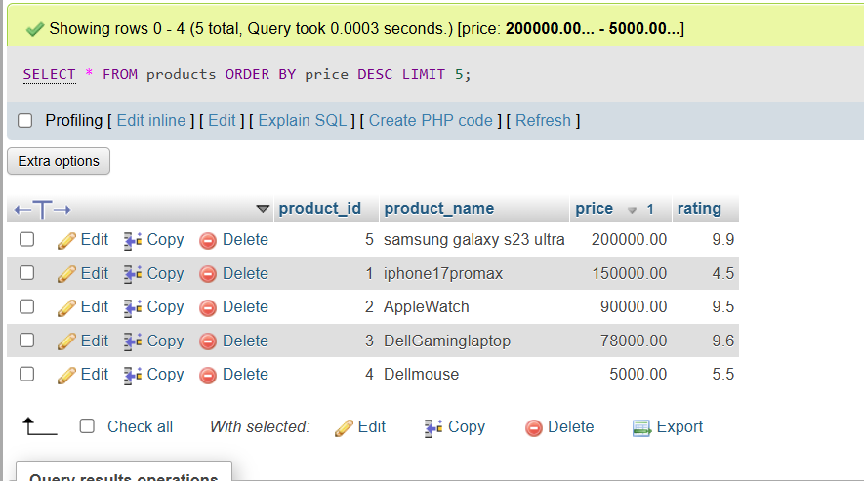

Q3 | Given a 'movies' table with columns 'title', 'release_year', and 'rating', write an SQL query to list all movies sorted first by release_year in descending order (latest first), then by rating in descending order (highest rated first).
Code | Create table movie  CREATE TABLE movies ( movie_id INT AUTO_INCREMENT, title VARCHAR(100), release_year INT, rating DECIMAL(3,1), PRIMARY KEY(movie_id) );  Insert record:  INSERT into movies(title,release_year,rating) VALUES ('The Shawshank Redemption',1994,9.3), ('The GodFather',1972,9.2), ('The Dark Knight',2008,9.0), ('12 Angry Men',1957,9.0), ('The Lord of the Rings: The Return of the King ',2003,9.0);  Show table:  SELECT * FROM movies;  Execute query:  SELECT * FROM movies ORDER BY release_year DESC, rating DESC;
Output | 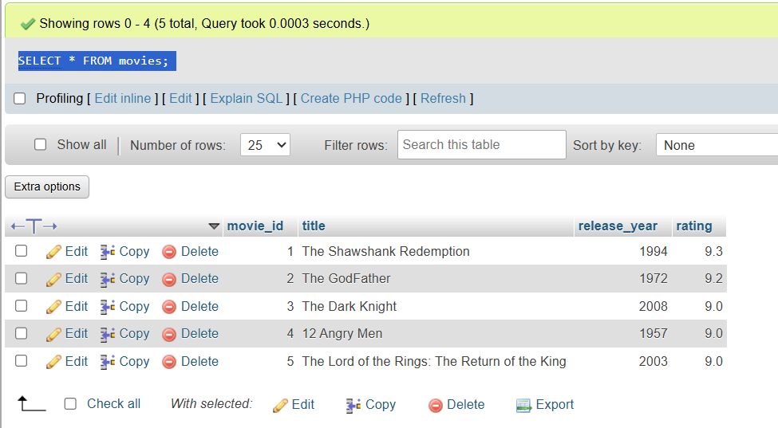  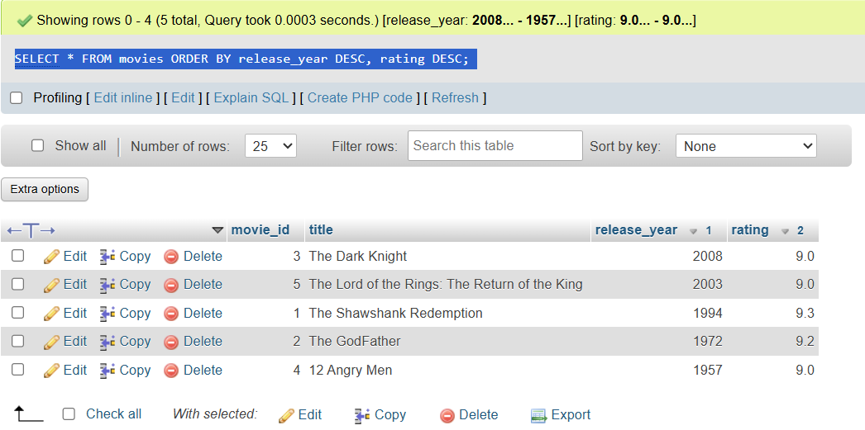

Q4 | Write an SQL query to display the first 10 restaurants from a 'restaurants' table, sorted alphabetically by name, just like Zomato's A-Z listing.<br><br><em><strong>Hint:</strong> Use ORDER BY with LIMIT.</em>
Code | Restaurants table already exists:  Execute query:  SELECT * FROM restaurants ORDER BY name ASC LIMIT 10;
Output | 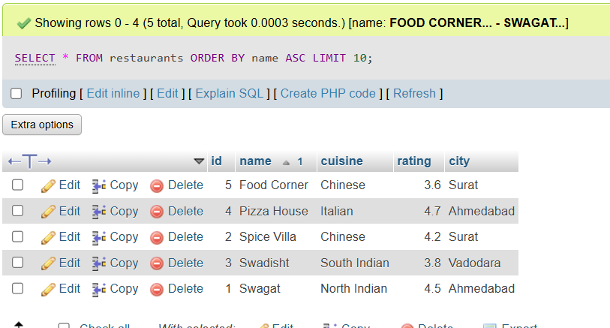

Q5 | Suppose you want to display the top 3 trending songs from a 'songs' table based on play_count, but if two songs have the same play_count, the more recently added song should come first. Write the SQL query to achieve this.<br><br><em><strong>Hint:</strong> Use ORDER BY with multiple columns.</em>
Code | Create table song:  CREATE TABLE songs ( song_id INT AUTO_INCREMENT, song_name VARCHAR(100), play_count INT, added_date DATE, PRIMARY KEY(song_id) );  Insert record:  INSERT INTO songs(song_name,play_count,added_date) VALUES ('Let me love you',5000,'2024-01-10'), ('Shape of you',8000,'2024-05-01'), ('Infinity',8000,'2024-06-01'), ('Agar tum sath ho',6000,'2024-04-10'), ('Dacular',10000,'2024-02-20');  Show table:  SELECT * FROM songs;  Execute query:  SELECT * FROM songs ORDER BY play_count DESC, added_date DESC LIMIT 3;
Output | 